D20v11

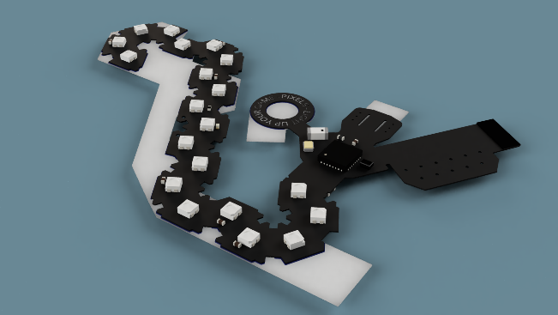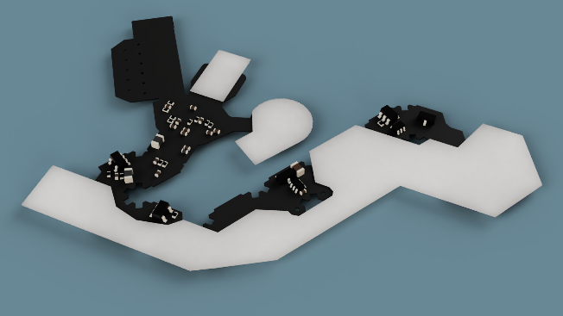

PCB Type : Flexible PCB

Board type : Single pieces

Layer : 2 Layers

Material : Polyimide Flex:

FPC Thickness : 0.13 mm

Solder Mask (Coverlay) : Black Coverlay

Silkscreen : White

Gold fingers : No

Stiffener : BOTTOM PI : 0.15 mm

Outline filename: *Main-B_Stiffener.gbr*

Surface Finish : Immersion gold (ENIG) (1U")

Finished Copper : 0.5 oz **Annealed** Cu (18μm)

E-test : 100%

3M/Tesa tape : TOP

Glue Outline filename: *Main-F_ Glue.gbr*

Backing Tape Outline filename: *Main-F_Tape.gbr*

SMT: TOP + BOT